Programming Assignment 1

Submitted By

Soumak Mookherjee & Shubhankar Benerjee

Computer Vision, Fall 2016

# Introduction

Content-based image retrieval is a way of image search where images are compared based on their content and retrieved from database. In this assignment we have developed three different methods for content based image retrieval and applied them to a database of 1000 images of ten categories. First we used color histogram intersection to find the match. Then, we improved the result by using spectral histogram. Finally, we used SIFT feature descriptor to find the match. We provide here first a brief discussion of all three methods and then precision-recall curves for a good case and a bad case for some category of images. Finally, we plot the average precisions and average ranks for all ten categories.

# Algorithms:

We have used three algorithms for this project. They are discussed below.

## Color Histogram:

1. Compute histograms for 3 color channels for all the images using 256 bins.
2. For each query image, calculate the match using histogram intersection. Add the histogram intersection values for 3 colors and use the sum as the match. Store the category and the match value in a list.
3. Sort the match list in ascending order.
4. Vary the number of image to be retrieved from 1 to 100 and calculate average precision and average rank and store this information in a list.
5. Compute the average precision and average ranks for each category.

## Spectral Histogram:

1. Follow steps for color histogram except for histogram computation use a filtered image.
2. We have Gaussian filter with sigma of 0.5.

## SIFT Descriptor

1. Compute SIFT feature descriptor for each image and store in corresponding files. (We have used SIFT binary package from VLFeat.org)
2. For each query image, compute the match between the query image and all the other image by comparing SIFT feature descriptors. (We have used angular distance for this purpose http://www.janeriksolem.net/2011/06/another-python-interface-for-sift.html). Store the category and the match value in a list.
3. Sort the match list in ascending order.
4. Vary the number of image to be retrieved from 1 to 100 and calculate average precision and average rank and store this information in a list.
5. Compute the average precision and average ranks for each category.

# Result:

We first present the average precisions and average ranks values for all ten categories for each method along with their plots. Since we only tried with Gaussian filter, we did not see improvement with spectral histogram. If we use four or five filters, then we would see improvement in the result. Our SIFT feature descriptor based image retrieval method also did not improve the result, as our match function is not well optimized for image retrieval.

# Average Precision and average ranks:

We mark the EXTRA CREDIT by bold red color. **We got 15 extra credits**.

## Color Histogram:

Table 1: Average precision and Average

ranks for color histogram method

|  |  |  |
| --- | --- | --- |
| 1 | **0.665385** | 181.8187 |
| 2 | 2.98E-01 | 3.61E+02 |
| 3 | 3.15E-01 | 3.46E+02 |
| 4 | **0.401241** | **207.4939** |
| 5 | 0.950928 | 70.5973 |
| 6 | **0.484883** | 239.2303 |
| 7 | **0.549116** | **280.4217** |
| 8 | 0.640792 | 310.634 |
| 9 | 2.21E-01 | 3.88E+02 |
| 10 | **0.492487** | **269.4929** |

## Spectral Histogram:

Table 2: Average precision and Average

ranks for spectral histogram method

|  |  |  |
| --- | --- | --- |
| 1 | **0.632982** | 189.806 |
| 2 | 2.85E-01 | 3.68E+02 |
| 3 | 3.06E-01 | 3.50E+02 |
| 4 | 0.317435 | **239.7468** |
| 5 | 0.956269 | 69.1058 |
| 6 | **0.467234** | 249.2264 |
| 7 | **0.524559** | 300.3122 |
| 8 | 0.614593 | 332.68 |
| 9 | 2.11E-01 | 3.94E+02 |
| 10 | **0.448652** | 278.5784 |

Table 3: Average precision and Average

ranks for SIFT Descriptor method

|  |  |  |
| --- | --- | --- |
| 1 | 0.161107 | 454.3488 |
| 2 | 0.133870 | 541.5492 |
| 3 | 0.236049 | 386.5155 |
| 4 | **0.464574** | **221.8022** |
| 5 | 0.672040 | 137.7013 |
| 6 | 0.190559 | 454.8141 |
| 7 | 0.340589 | 408.7771 |
| 8 | 0.170553 | 605.6970 |
| 9 | 0.195576 | 426.2766 |
| 10 | 0.194108 | 430.4672 |

## Average Precision Plot:

**Average Rank Plot**:

# Precision-Recall Curve:

We present the precision-recall curves for one good case and one bad case for category 1, 5 and 9.

## Color Histogram:

Category 1 – Good Case



Category 1 – Bad Case



Category 5 - Good Case

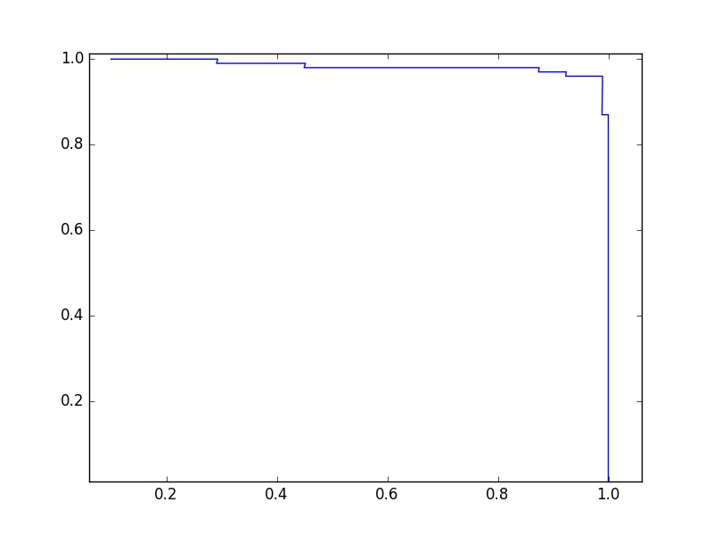

Category 5 - Bad Case

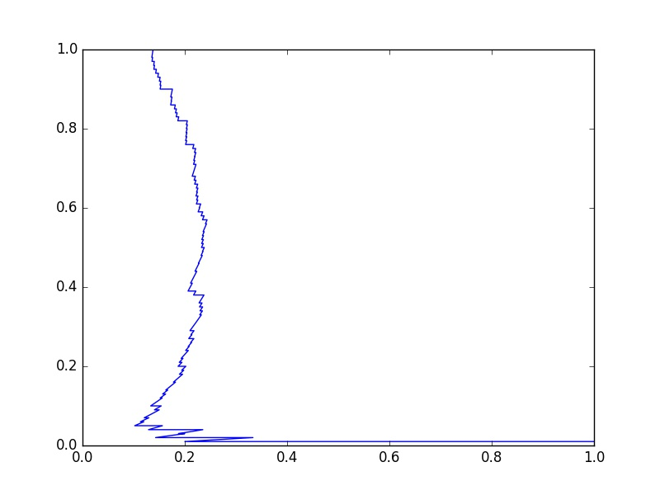

Category 9- Good Case

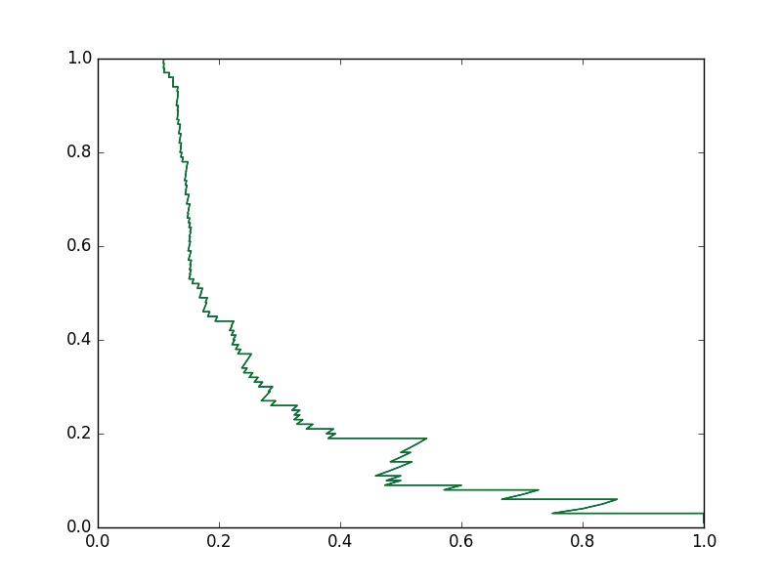

Category 9 - Bad Case

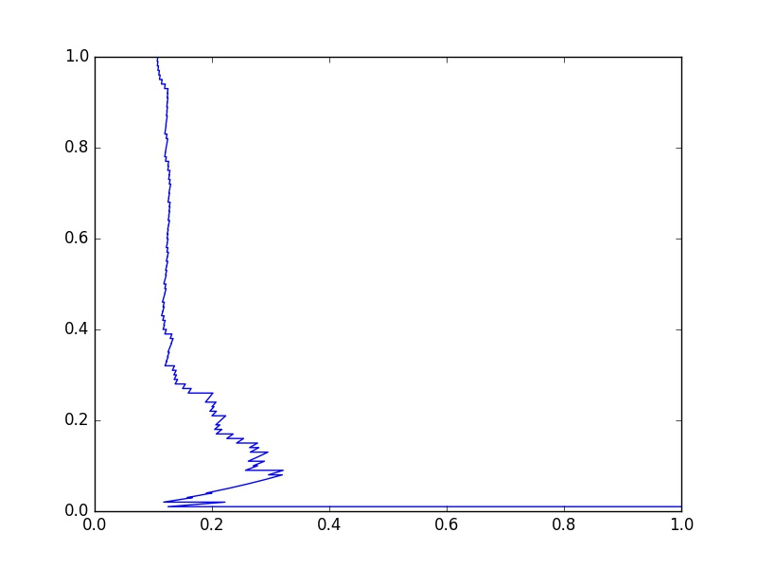

# Spectral Histogram:

Category 1 – Good Case



Category 1 – Bad Case



Category 5 - Good Case



Category 5 - Bad Case



Category 9- Good Case



Category 9 - Bad Case



SIFT Feature Descriptor:

Category 1 – Good Case

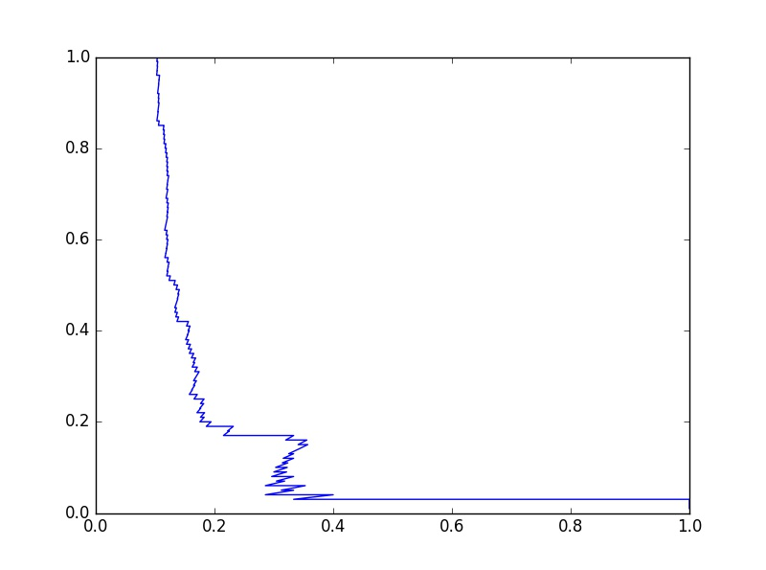

Category 1 – Bad Case

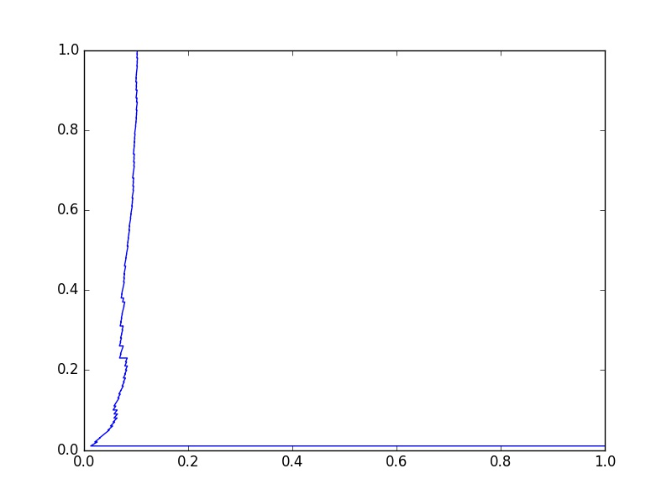

Category 5 - Good Case

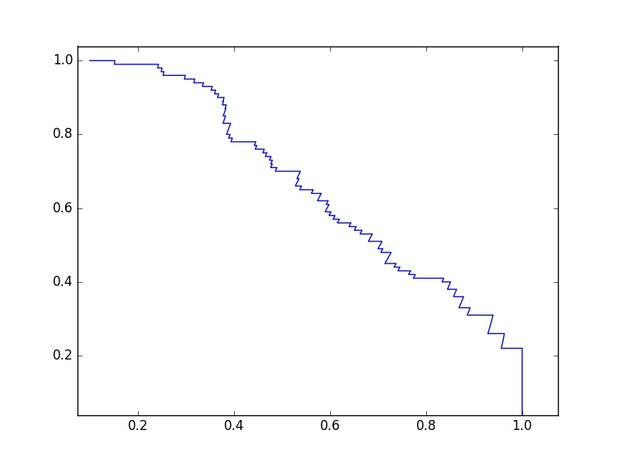

Category 5 - Bad Case

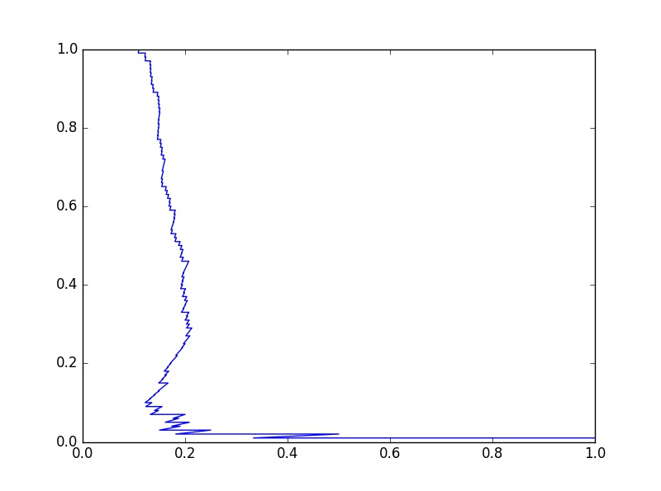

Category 9- Good Case

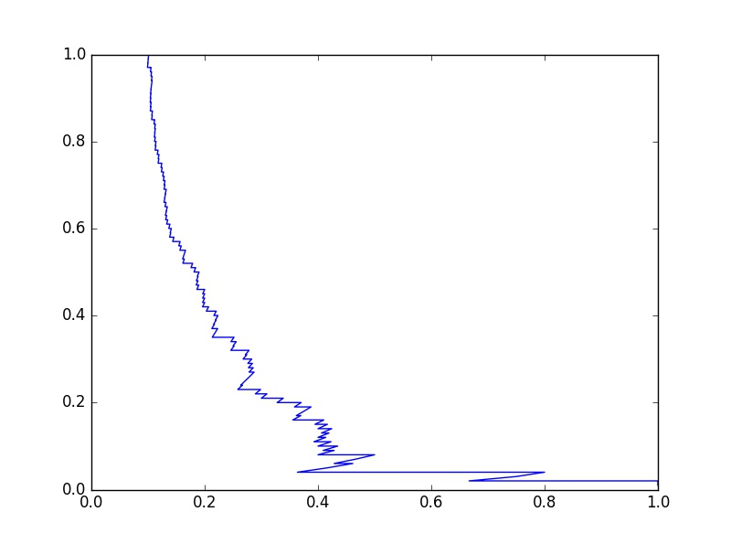

Category 9 - Bad Case

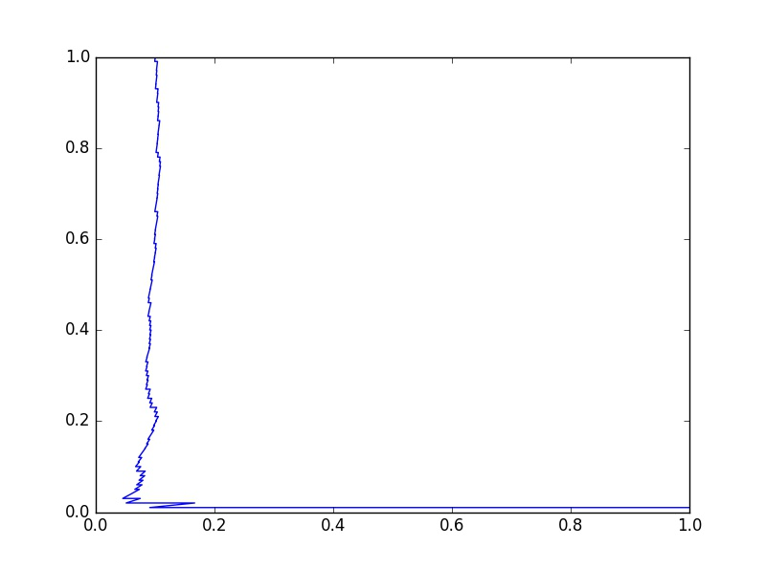

Source Code:

1. Color Histogram

# -*- coding: utf-8 -*-

"""

Created on Sun Sep 18 08:53:22 2016

@author: Soumak

"""

import matplotlib

import matplotlib.pyplot as plt

import matplotlib.image as mpimg

import numpy as np

import math

TOTAL_NO = 1000

NO_OF_CLASS = 10

NO_EACH_CLASS = 100

#hist_r=[0]*256

#hist_g=[0]*256

#hist_b=[0]*256

def compute_hist(img):

"""

input = image with 3 color channels

returns : 3 histogram as 3 lists

"""

row = img.shape[0]

col = img.shape[1]

red = img[:,:,0]

green = img[:,:,1]

blue = img[:,:,2]

hist_r=[0]*256

hist_g=[0]*256

hist_b=[0]*256

for i in range(row):

for j in range(col):

p=red[i,j]

hist_r[p] += 1.0/(row*col)

p=green[i,j]

hist_g[p] += 1.0/(row*col)

p=blue[i,j]

hist_b[p] += 1.0/(row*col)

return hist_r, hist_g, hist_b

#hist_list is the list of tuples

# It will hold class information and histtograms for 3 channels

hist_list = []

for i in range(TOTAL_NO):

fname = 'image.orig/'+ str(i) + '.jpg'

img = plt.imread(fname)

hist_r, hist_g, hist_b = compute_hist(img)

hist_list.append((i//NO_EACH_CLASS, hist_r, hist_g, hist_b))

#declare a list which will hold a tuple of average precision and rank

#for each query image

pr_list = []

new_hist_list = []

for k in range(TOTAL_NO):

##query image

fname = 'image.orig/'+ str(k) + '.jpg'

img = plt.imread(fname)

hist_r, hist_g, hist_b = compute_hist(img)

#copy hist_list

new_hist_list = hist_list[:]

#remove query image from dataset

# new_hist_list.remove((k//NO_EACH_CLASS, hist_r, hist_g, hist_b))

##compute histogram intersection

#

match = []

for i in range(TOTAL_NO):

HI_r =0

HI_g =0

HI_b =0

for j in range(256):

HI_r += min(hist_r[j],new_hist_list[i][1][j])

HI_g += min(hist_g[j],new_hist_list[i][2][j])

HI_b += min(hist_b[j],new_hist_list[i][3][j])

HI = HI_r + HI_g + HI_b

#store the category and Histogram Intersection value

match.append((new_hist_list[i][0],HI))

#sort match

sorted_match = sorted(match, key=lambda x: x[1], reverse=True)

#calculate precision & rank

p_av = 0.0

ml = 0

r = 0

count = 0

for i in range(0,TOTAL_NO):

#if the image is relevant, increment ml

if sorted_match[i][0] == k//NO_EACH_CLASS:

if i < 100:

ml += 1.0

r += float(i)

count += 1

if count == 100:

break

if i < 100:

p_av += ml/(i+1)

#divide by 100 to get average precision and rank

p_av = p_av/100.0

r_av = r/100.0

pr_list.append((p_av, r_av))

#calculate average of average precision and average rank for each class

class_pr = []

for i in range(NO_OF_CLASS):

class_pr.append(np.sum(pr_list[i*NO_EACH_CLASS:(i+1)*NO_EACH_CLASS], axis=0)/NO_EACH_CLASS)

print( class_pr[i])

#plt.plot(p_av,r_av)

#plt.xlim([0,1])

#plt.ylim([0,1])

1. Spectral Histogram

# -*- coding: utf-8 -*-

"""

Created on Sun Sep 18 08:53:22 2016

@author: Soumak

"""

import matplotlib

import matplotlib.pyplot as plt

import matplotlib.image as mpimg

import numpy as np

import math

from scipy.ndimage import filters

TOTAL_NO = 1000

NO_OF_CLASS = 10

NO_EACH_CLASS = 100

SIGMA=0.5

def compute_hist(img):

"""

input = image with 3 color channels

returns : 3 histogram as 3 lists

"""

row = img.shape[0]

col = img.shape[1]

red = img[:,:,0]

green = img[:,:,1]

blue = img[:,:,2]

hist_r=[0]*256

hist_g=[0]*256

hist_b=[0]*256

for i in range(row):

for j in range(col):

p=red[i,j]

hist_r[p] += 1.0/(row*col)

p=green[i,j]

hist_g[p] += 1.0/(row*col)

p=blue[i,j]

hist_b[p] += 1.0/(row*col)

return hist_r, hist_g, hist_b

#hist_list is the list of tuples

# It will hold class information and histtograms for 3 channels

hist_list = []

for i in range(TOTAL_NO):

fname = 'image.orig/'+ str(i) + '.jpg'

img_orig = plt.imread(fname)

#use filtered image

img = filters.gaussian_filter(img_orig,SIGMA)

hist_r, hist_g, hist_b = compute_hist(img)

hist_list.append((i//NO_EACH_CLASS, hist_r, hist_g, hist_b))

#declare a list which will hold a tuple of average precision and rank

#for each query image

pr_list = []

for k in range(TOTAL_NO):

##query image

fname = 'image.orig/'+ str(k) + '.jpg'

img_orig = plt.imread(fname)

#use filtered image

img = filters.gaussian_filter(img_orig,SIGMA)

hist_r, hist_g, hist_b = compute_hist(img)

##compute histogram intersection

#

match = []

for i in range(TOTAL_NO):

HI_r =0

HI_g =0

HI_b =0

for j in range(256):

HI_r += min(hist_r[j],hist_list[i][1][j])

HI_g += min(hist_g[j],hist_list[i][2][j])

HI_b += min(hist_b[j],hist_list[i][3][j])

HI = HI_r + HI_g + HI_b

#store the category and Histogram Intersection value

match.append((hist_list[i][0],HI))

#sort match

sorted_match = sorted(match, key=lambda x: x[1], reverse=True)

#calculate precision & rank

p_av = 0.0

ml = 0

r = 0

count = 0

for i in range(0,TOTAL_NO):

#if the image is relevant, increment ml

if sorted_match[i][0] == k//NO_EACH_CLASS:

if i < 100:

ml += 1.0

r += float(i)

count += 1

if count == 100:

break

if i < 100:

p_av += ml/(i+1)

#divide by 100 to get average precision and rank

p_av = p_av/100.0

r_av = r/100.0

pr_list.append((p_av, r_av))

#calculate average of average precision and average rank for each class

class_pr = []

for i in range(NO_OF_CLASS):

class_pr.append(np.sum(pr_list[i*NO_EACH_CLASS:(i+1)*NO_EACH_CLASS], axis=0)/NO_EACH_CLASS)

print( class_pr[i])

1. SIFT Descriptor

# -*- coding: utf-8 -*-

"""

Created on Sun Sep 18 08:53:22 2016

@author: Soumak

"""

from PIL import Image

import os

import matplotlib

import matplotlib.pyplot as plt

import matplotlib.image as mpimg

import numpy as np

import cv2

TOTAL_NO = 1000

NO_OF_CLASS = 10

NO_EACH_CLASS = 100

#feature_list is the list of tuples

# It will hold class information and feature descriptor for each image

feature_list = []

for i in range(TOTAL_NO):

fname = 'image.orig/'+ str(i) + '.jpg'

img = cv2.imread(fname)

sift = cv2.SIFT()

kp1, des1 = sift.detectAndCompute(img,None)

feature_list.append((i//NO_EACH_CLASS, des1))

#declare a list which will hold a tuple of average precision and rank

#for each query image

pr_list = []

for k in range(TOTAL_NO):

##query image

des1 = feature_list[k][1]

##compute feature match

#

match_list = []

for i in range(TOTAL_NO):

des2 = feature_list[i][1]

bf = cv2.BFMatcher()

# Match descriptors.

matches = bf.match(des1,des2)

# Sort them in the order of their distance.

matches = sorted(matches, key = lambda x:x.distance)

M_SUM = matches[0].distance

#store the category and Histogram Intersection value

match_list.append((feature_list[i][0],M_SUM))

#sort match

#smaller match is best

sorted_match = sorted(match_list, key=lambda x: x[1])

#calculate precision & rank

p_av = 0.0

ml = 0

r = 0

count = 0

for i in range(0,TOTAL_NO):

#if the image is relevant, increment ml

if sorted_match[i][0] == k//NO_EACH_CLASS:

if i < 100:

ml += 1.0

r += float(i)

count += 1

if count == 100:

break

if i < 100:

p_av += ml/(i+1)

#divide by 100 to get average precision and rank

p_av = p_av/100.0

r_av = r/100.0

pr_list.append((p_av, r_av))

#calculate average of average precision and average rank for each class

class_pr = []

for i in range(NO_OF_CLASS):

class_pr.append(np.sum(pr_list[i*NO_EACH_CLASS:(i+1)*NO_EACH_CLASS], axis=0)/NO_EACH_CLASS)

print( class_pr[i])